Purpose
In order to protect each person that works or visits the Energy Innovation Center, we will take action for compliance with regulations and protection of people. Appropriate protective equipment is required in areas where there may be a risk of injury or exposure to hazardous substances or conditions. This program defines how the EIC is to achieve objectives to protect people from various hazards encountered in the areas where they may work or visit.

Scope
The use of appropriate personal protective safety equipment applies to employees and non-employees performing tasks involving hazards and/or entering areas that require specific Personal Protective Equipment (PPE).
Other requirements for the use of specialized PPE are defined for specific hazards in the respective safety policy / program:
- Fall Protection
- Electrical Safety
- Power Industrial Trucks
- Hand and Power Tools

Reference Standard
Occupational Safety and Health Administration: 29 CFR 1910 Subpart I

Responsibilities
The EIC has the responsibility to protect the employee and visitor from injury. Hazards should be evaluated, controlled or eliminated, if possible, prior to the start of any work where hazards have been identified. If hazards cannot be eliminated, then hazard controls and protective equipment should be utilized to ensure the safety of all.

EIC Management
- The EIC Management is responsible for providing the necessary PPE.
- The EIC Management is responsible for ensuring that employees wear the required PPE.
- The EIC Management is must verify that employees have PPE training regarding:
  - When PPE is necessary
  - What type to use
  - How to put on, take off, adjust, and wear appropriate PPE
  - The proper maintenance, storage, disposal and useful life of PPE

Employees and Non-employees
- Each individual is responsible for wearing his/her required PPE.
- Each individual must ensure that his/her PPE is in good operating condition before wearing it.
- Each individual is responsible for maintaining and storing his/her PPE in an appropriate location and condition.
- Each individual needs to report to his/her supervisor any defective PPE or need for replacement.

Occupational and Environmental Safety
- The Lowcountry Safety Manager will assist the EIC management in completing the PPE Assessment.

Definitions

Eye/Face Protection - Equipment designed to provide protection to the face and eyes during exposure to such hazards as flying particles, molten metal or sparks, liquid chemicals, acids or caustic liquids, or potentially injurious light radiation (i.e., lasers, welding, etc.)
Foot Protection - Equipment designed to provide protection to the feet and toes during exposure to situations with the potential for foot injuries such as falling or rolling objects, chemical or liquid exposures, piercing objects through the sole or uppers, and/or where there is exposure to electrical hazards.
Hand Protection - Equipment designed to provide protection to the hands during exposures to potential hazards such as sharp objects, abrasive surfaces, temperature extremes and chemical contact. Hand protection is selected based upon the hazard and performance characteristics of the gloves.
Head Protection - Equipment designed to provide protection to the head during exposure to potential hazards such as falling objects, striking against low hanging objects, or electrical hazards.
Hearing Protection - Equipment designed to provide protection to an individual's hearing during exposure to high noise levels.
Personal Protective Equipment (PPE) - Includes all equipment designed to provide protection to the wearer from potential hazards to the eyes, face, hands, head, feet, ears, and extremities.
Respiratory Protection - Equipment designed to provide protection to the wearer from potential inhalation hazards such as vapors, mists, particulates, and gases.

Procedure

The purpose of personal protective equipment (PPE) is to protect individuals exposed to hazards by creating a barrier against workplace hazards. Engineering control of hazards is the first action. PPE control is the last resort which includes devices for head protection, eye and face protection, protective clothing, hand protection, foot protection, hearing and respiratory protection. Using PPE requires hazard awareness and training on the part of the user. PPE is not a substitute for good engineering or administrative controls or good work practices but should be used in conjunction with these controls.

PPE Assessment
In order to be able to choose the proper PPE, the individual must be aware of what hazards exist in the workplace. The PPE Assessment is an integral part of the Safety Task Analysis and Electrical Safety Task Analyses. An area PPE assessment of the EIC is conducted periodically to ensure the minimum PPE requirements. (See Appendix for updated facility assessment)

Head Protection
Head injuries are commonly caused by impact from falling or flying objects or walking into hard objects. PPE devices such as hard hats may protect you from objects falling on your head and, in a limited way, from electrical shock or burns. Hard hats should be worn in areas when there is potential for a head injury. In areas where overhead bridge cranes are being used, at a minimum, a hard hat must be worn within the perimeter of the crane rails when lifting is being performed. Also, when overhead work is being performed, a hardhat must be worn when in the lift and when you are in proximity to the overhead work. Overhead work consists of use of crane, rigging, aerial lift, man-lift and work on mezzanines and elevated platforms. EIC hardhats meet ANSI Z89.1 requirements and are Type 1, Class E

Eye and Face Protection
Eye protection must be worn where there is potential for injury to the eyes or face from small particles, toxic chemicals, flying objects or particles, large objects, thermal or radiation hazards, and lasers. According to the types of and extent of hazards, different PPE should be worn. PPE for the face and eyes includes devices such as safety glasses, goggles, and face shields. These must always remain clean and free of contaminants.
For employees who wear prescription glasses, side shields must be permanently affixed to the frames to protect eyes from flying particles. Side shields on eyeglass frames must meet ANSI Z87.1 requirements and must not be removed. The Clemson eyeglass program uses a designated vendor to provide preapproved glasses to employees. This is a reduced cost program under state contract. This program will provide up to $130 per year. Employees are responsible for additional fees associated with the eye examination, fitting, dispensing and options such as tinting. (SEE APPENDIX B FOR PURCHASING PROCEDURE)
Part-time employees should be provided temporary safety glasses that can be placed over their personal prescription glasses. “Over-the-glasses” safety glasses are available.

Hand Protection
Hand protection shall be dictated by the hazards. For general industrial work, gloves are recommended to prevent small injuries. Nitrile gloves are recommended for sanitary use. Cut resistant Kevlar gloves are recommended for handling sharp objects where cuts are more likely.

Foot Protection
The appropriate foot protection shall be worn in the work areas designated by the area PPE assessment. Where designated, steel toe or composite toe shoes shall be worn to prevent foot injury. The EIC will reimburse full-time employees for safety shoes up to a maximum of $150 annually.

Hearing Protection
Exposure to high levels of noise may result in hearing loss. PPE should be worn when the noise level has a time weighted average of 85 decibels or greater. Popular types of hearing protection devices include earmuffs and foam earplugs. Noise level testing has been performed throughout the EIC. No sound level was detected in working areas that were in excess of 85 dB on a TWA. The Main Hydraulic Room is a designated area for mandatory hearing protection when operating and hearing protection is mandatory for time intervals extending beyond 15 minutes.

Respiratory Protection
The EIC does not have any identified respiratory hazards that require fit tested respirators. There are many hazards that may require the use of dust masks but are not considered a respirator requirement by OSHA standards.

Training Requirements
Employees are initially trained in proper use and maintenance of any PPE required in accordance with the manufacturers' instructions. Employee training shall be conducted in a period not to exceed 3 years thereafter. Failure to adhere to this procedure may require retraining for the employee.

Revision History

Revision | Date | Summary of change | Author | Approver
A | 12/8/2020 | Initial issue | Kurt Rayburg | SSC
A | 7/26/22 | PPE Assessment updated, eyeglass program added. | Kurt Rayburg | Pending SSC

HAZARD ASSESSMENT:
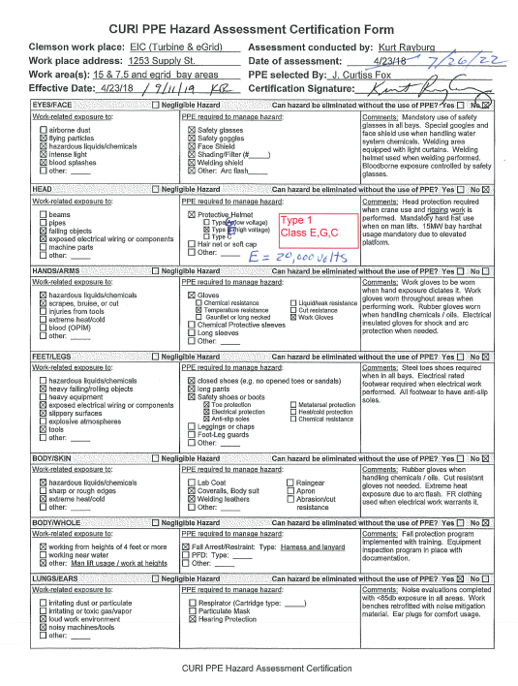
SAFETY EYEGLASS PROGRAM:
Clemson has implemented a prescription safety glasses program for those requiring eye protection as part of their job duties. This program is a partnership between Safevision / HOYA, VWR, and Clemson. This program provides selection of high quality, professionally fitted, prescription safety glasses at a moderate price. This program does not include an eye exam and a current prescription is required at the time of fitting.

The sequence of steps to obtain prescription safety glasses is outlined below. For specific questions, please contact Chris Weber (cweber2@clemson.edu).

- Supervisors who have a Clemson employee that would like prescription safety glasses should complete a hazard assessment form to confirm that the employee’s job duties require the use of eye protection.
- Supervisors should submit the hazard assessment form (keep a copy for your records), along with the employee’s name and department to Chris Weber and indicate they would like to purchase glasses.
- A VWR quote will be generated for the employee and returned to the supervisor. The cost per pair of glasses is $130.00 (+tax). Supervisors are responsible for identifying a purchase account to fund the glasses.
- The quote number is entered into the VWR “my quotes” tab in Buyways. The part is then added to the cart and purchased as normal in Buyways.
- VWR will generate a Safevision order form for the employee. This will be emailed to the supervisor within a few days.
- The Safevision order form is provided to the employee and brought (along with a current prescription) to the local eye care provider:

Outer Vision
1890 Sam Rittenberg Blvd. 107
Charleston, SC 29407
Tel: 843-763-2020
Fax: 843-763-2021

The employee will select frames (from a selection of approved frames that will be provided) and be fitted. The provider will place the order for fabrication. The glasses will be shipped to the provider when complete (2-3 weeks). The invoice is generated upon shipment. Note that a photochromic lens option is available, however, this is at the employee’s expense.

- When the provider receives the glasses, the employee will be contacted to pick them up and receive a final fit check.
- SEE BELOW ASSESSMENT FORM & PACKAGE INFORMATION.

PPE HAZARD ASSESSMENT FORM: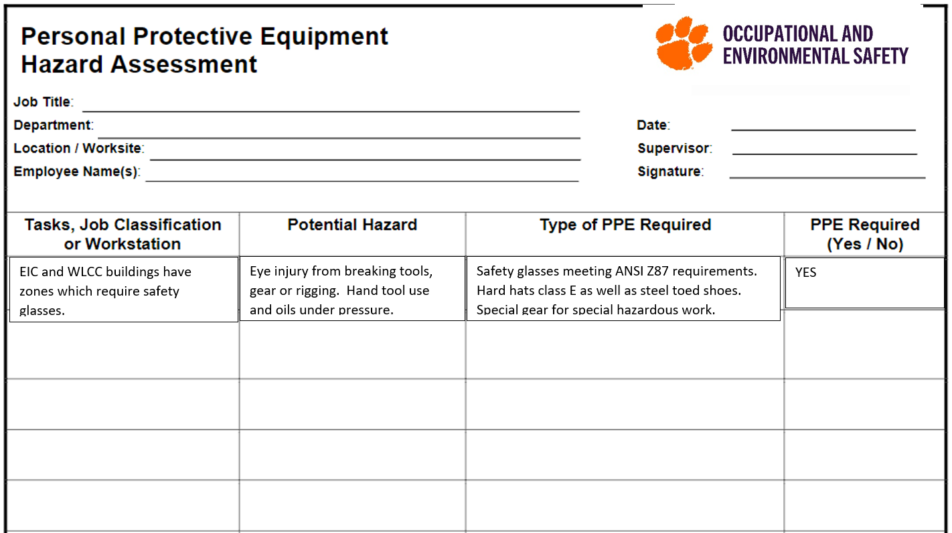PROGRAM INCLUDES PACKAGE 2 OPTIONS: